1. Go to core setups>>Types>>External Establishment setup

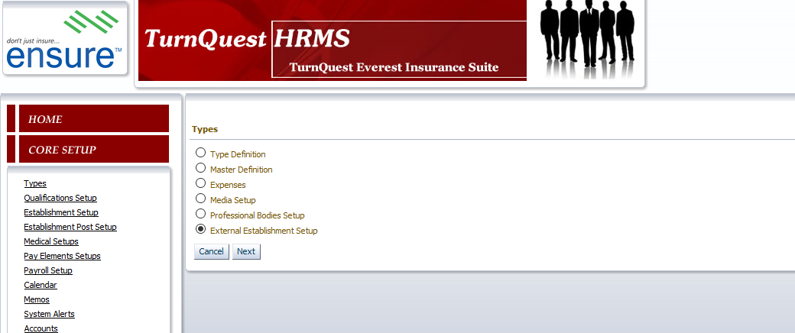

2.We have the Fund administrators and Fund custodian

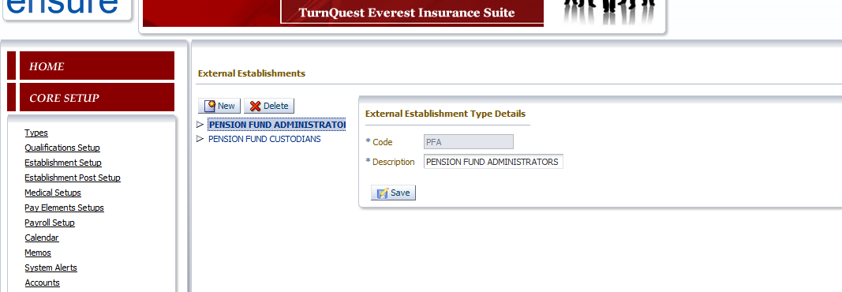

1. The fund administrators- LEADWAY PENSURE

Custodian-UBA

1. However when you go to

Payroll>>Personnel payment details, select PEJU

The Administrator has been tagged wrongly ie UBA is custodian and not administrator

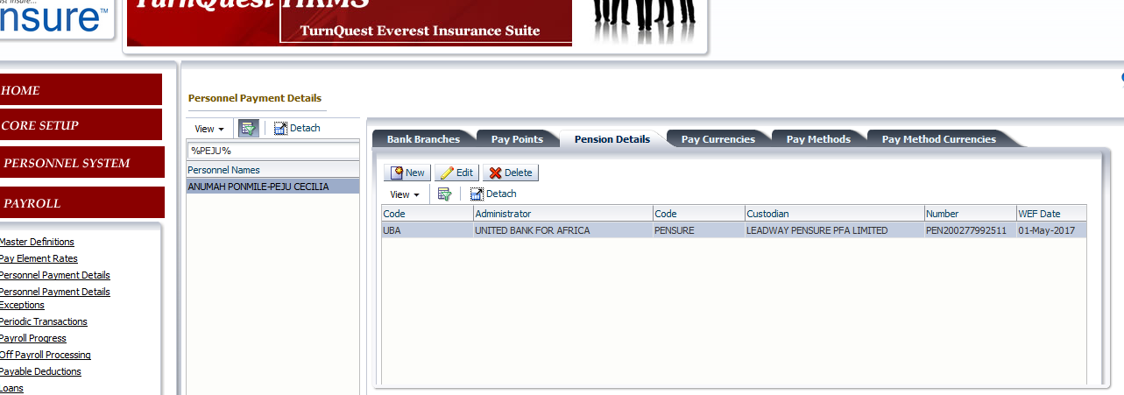

Correct it to read as below

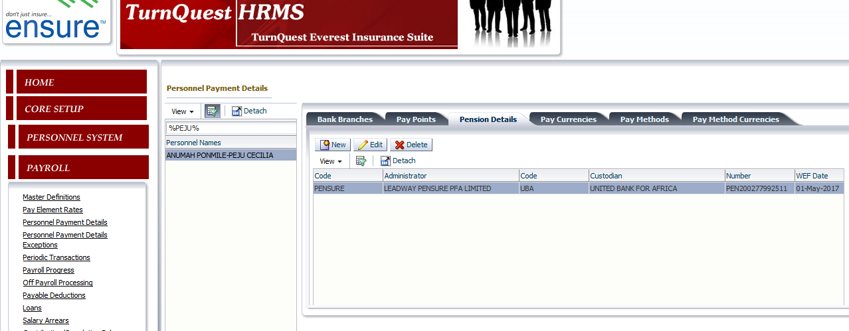

Run the pension report after correcting

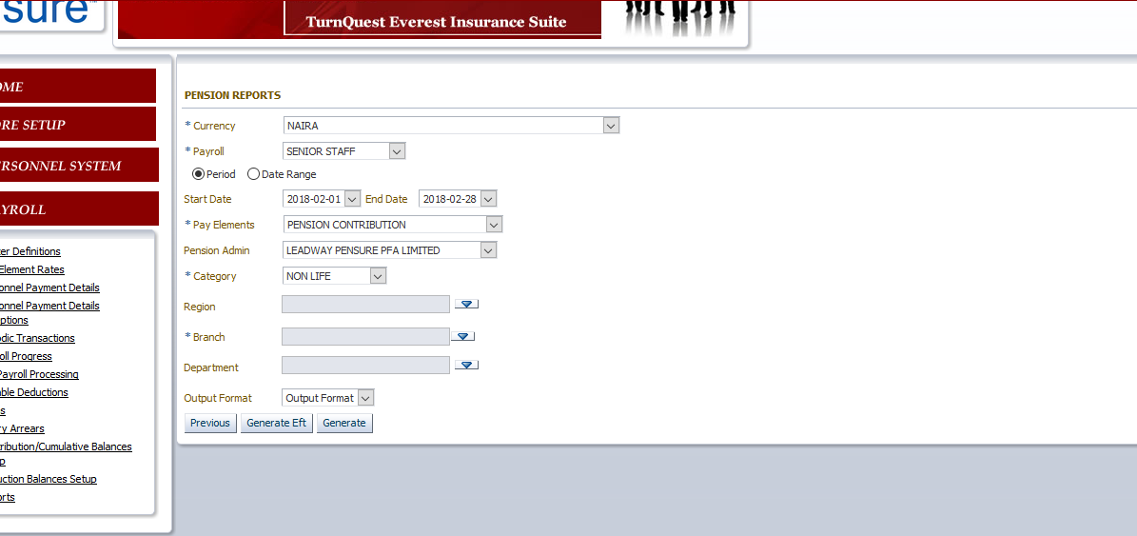

PEJU showing

